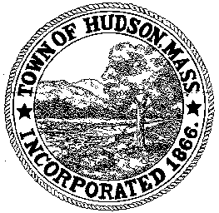

CONSERVATION COMMISSION
78 Main Street, Hudson, MA 01749
(978) 562-2020

Paul Byrne, Chairman W. Minot Wood, Vice Chairman David Esteves, Member

Terrence Joyce, Member Leif Longtine, Member Joseph Rodrigues, Member Al Tashian, Member

Meeting Minutes
April 7, 2011
- Preliminaries
  - Meeting was called to order at 7:00PM
  - Roll Call: Paul Byrne, Terrence Joyce, David Esteves, Leif Longtine, Joe Rodrigues, Minot Wood

2.0 New Business
2.1 DEP 190-0557 continued
Location: 146 Main Street
Applicant: Jose and Maria Peneda
Project Description: Demolition of a portion of the existing structures and the construction of an addition to the building at 146 Main Street, within the floodplain.
Minot motioned to close the public hearing and issue an Order of Conditions. Motion was seconded by Joe with all in favor, 6-0

2.2 RDA 404
Location: 31 Maple Street
Project Description: Removal of trees within the 100” riverfront area
Minot motioned to close the public hearing and issue a negative determination. Motion was seconded by Joe with all in favor 6-0

2.3 Request for Review and Comments: 201 Manning Street
noted

3.0 Old Business
Minutes March 17, 2011
Approved as written

4.0 Paul motioned to adjourn at 7:50 PM, seconded by Leif. Motion passed 6-0

